**ADMIN LOGIN TEST**

package bloodBank;

import org.openqa.selenium.By;

import org.openqa.selenium.WebDriver;

import org.openqa.selenium.chrome.ChromeDriver;

public class Admin_login {

public static void main(String[] args) {

System.setProperty("webdriver.chrome.driver","C:\\Users\\Lenovo\\Desktop\\

New folder\\chromedriver_win32\\chromedriver.exe");

WebDriver driver = new ChromeDriver();

driver.get("http://localhost/bloodbank%20and%20donar%20management%

20system/bbdms/admin/index.php");

driver.manage().window().maximize();

driver.findElement(By.id("uname")).sendKeys("admin");

driver.findElement(By.id("psw")).sendKeys("123456");

driver.findElement(By.id("btn")).click();

String a= driver.getTitle();

String b= "BBDMS | Admin Dashboard";

if(a.equalsIgnoreCase(b))

{

System.out.println("Admin Login Test Successfull");

}

else

{

System.out.println("Test Not Successfull");

}

//driver.close();

}

}

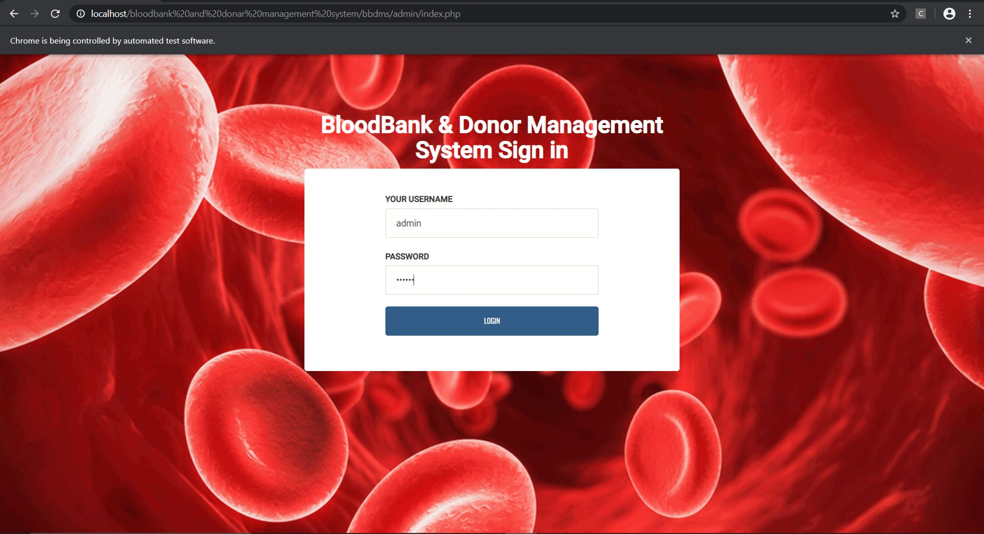

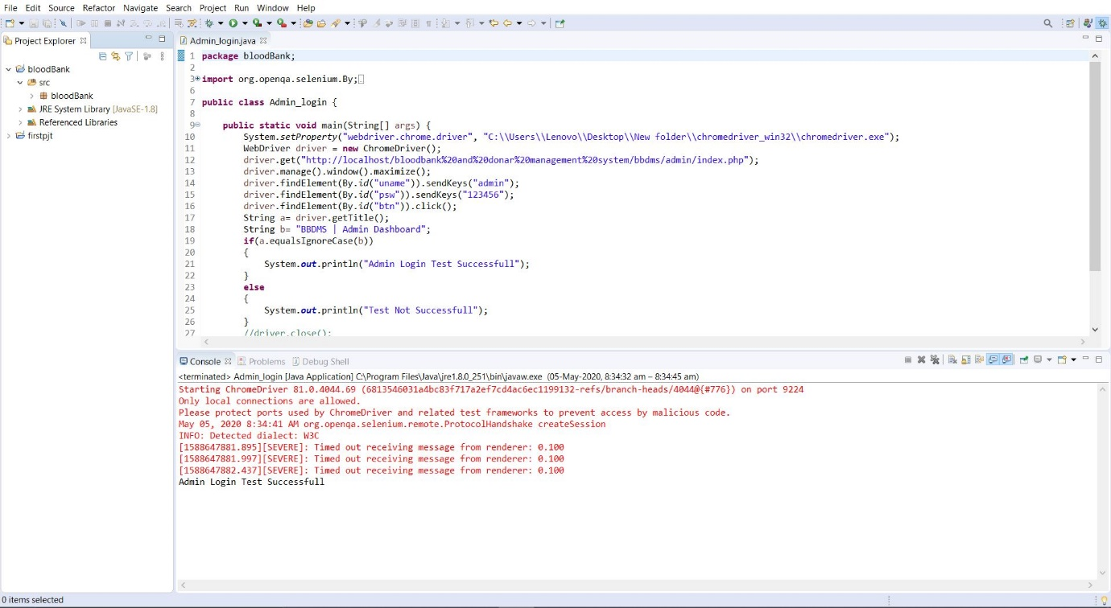

**ADMIN CHANGE PASSWORD**

package bloodBank;

import org.openqa.selenium.By;

import org.openqa.selenium.WebDriver;

import org.openqa.selenium.chrome.ChromeDriver;

public class adpaschng {

public static void main(String[] args) {

System.setProperty("webdriver.chrome.driver","C:\\Users\\Lenovo\\Desktop\\

New folder\\chromedriver_win32\\chromedriver.exe");

WebDriver driver = new ChromeDriver();

driver.get("http://localhost/bloodbank%20and%20donar%20management%

20system/bbdms/admin/index.php");

driver.manage().window().maximize();

driver.findElement(By.id("uname")).sendKeys("admin");

driver.findElement(By.id("psw")).sendKeys("123456");

driver.findElement(By.id("btn")).click();

driver.findElement(By.id("cpsw")).sendKeys("123456");

driver.findElement(By.id("npsw")).sendKeys("123");

driver.findElement(By.id("apsw")).sendKeys("123");

driver.findElement(By.id("btn1")).click();

String c= driver.findElement(By.className("succWrap")).getText();

String d= "SUCCESS:Your Password succesfully changed";

if(c.equalsIgnoreCase(d))

{

System.out.println("Admin Password changing Test Successfull");

}

else

{

System.out.println("Test Not Successfull");

}

//driver.close();

}

}

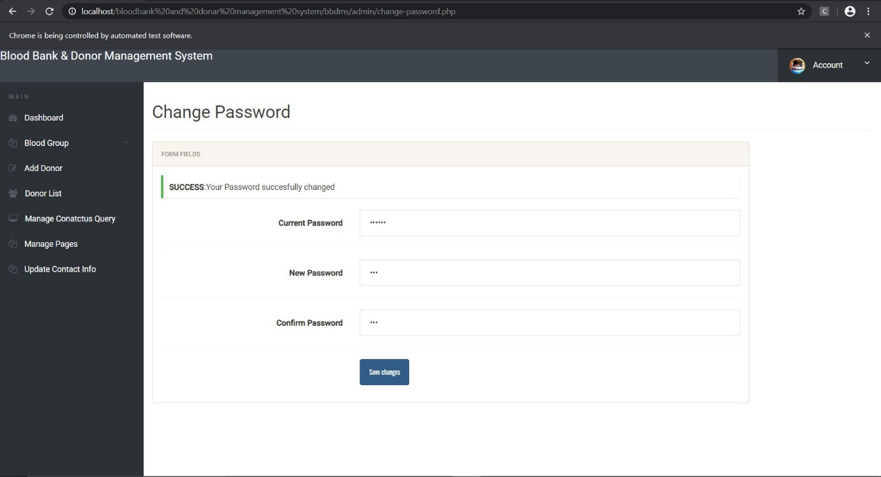

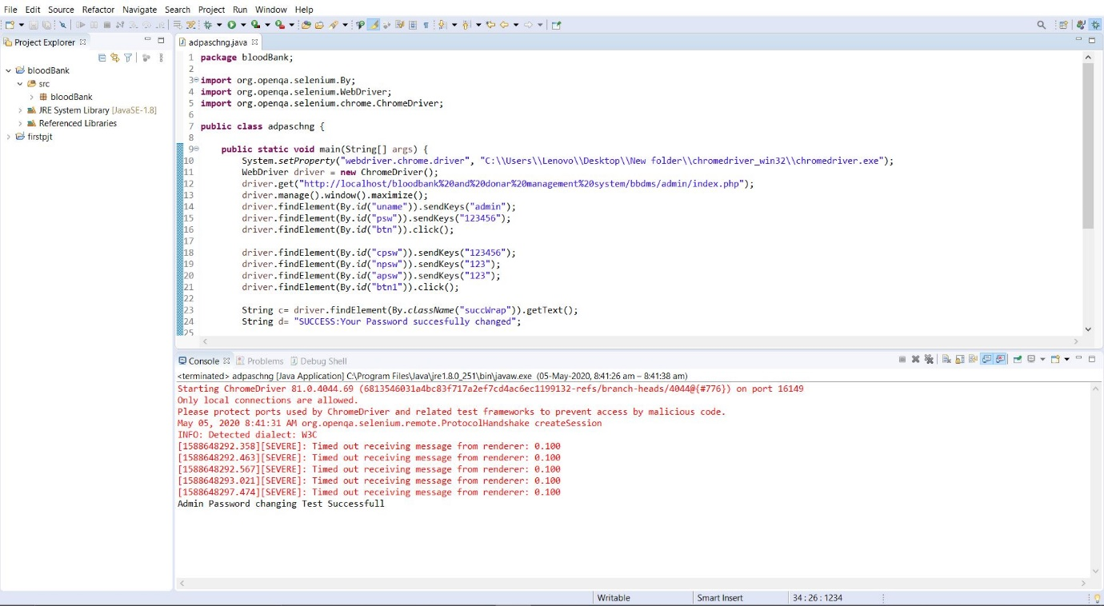

**DASHBOARD**

package bloodBank;

import org.openqa.selenium.By;

import org.openqa.selenium.WebDriver;

import org.openqa.selenium.chrome.ChromeDriver;

public class dash {

public static void main(String[] args) {

System.setProperty("webdriver.chrome.driver", "C:\\Users\\Lenovo\\Desktop\\

New folder\\chromedriver_win32\\chromedriver.exe");

WebDriver driver = new ChromeDriver();

driver.get("http://localhost/bloodbank%20and%20donar%20management%

20system/bbdms/admin/index.php");

driver.manage().window().maximize();

driver.findElement(By.id("uname")).sendKeys("admin");

driver.findElement(By.id("psw")).sendKeys("123456");

driver.findElement(By.id("btn")).click();

driver.findElement(By.id("dash")).click();

String e= driver.getTitle();

String f= "BBDMS | Admin Dashboard";

//driver.close();

if(e.equalsIgnoreCase(f))

{

System.out.println("Test admin dashboard Successfull");

}

else

{

System.out.println("Test Not Successfull");

}

driver.findElement(By.id("dash")).click();

driver.findElement(By.id("lbg")).click();

String a= driver.getTitle();

String b= "BBDMS | Admin Manage Blood groups";

if(a.equalsIgnoreCase(b))

{

System.out.println("Test List of RBG Successfull");

}

else

{

System.out.println("Test Not Successfull");

}

driver.findElement(By.id("dash")).click();

driver.findElement(By.id("rgb")).click();

String c= driver.getTitle();

String d= "BBDMS |Admin Manage Queries";

if(c.equalsIgnoreCase(d))

{

System.out.println("Test List of RBG Successfull");

}

else

{

System.out.println("Test Not Successfull");

}

driver.findElement(By.id("dash")).click();

driver.findElement(By.id("total")).click();

String g= driver.getTitle();

String h= "BBDMS |Admin Manage Queries";

if(g.equalsIgnoreCase(h))

{

System.out.println("Test List of Queries Successfull");

}

else

{

System.out.println("Test Not Successfull");

}

driver.close();

}

}

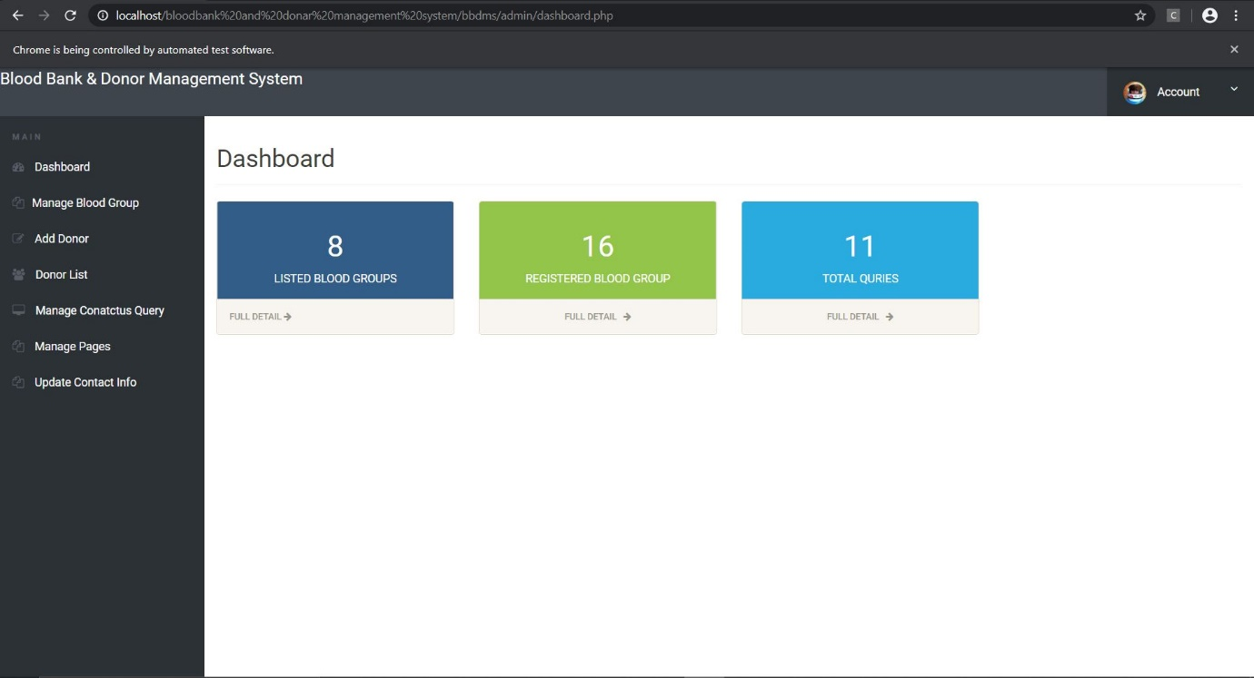

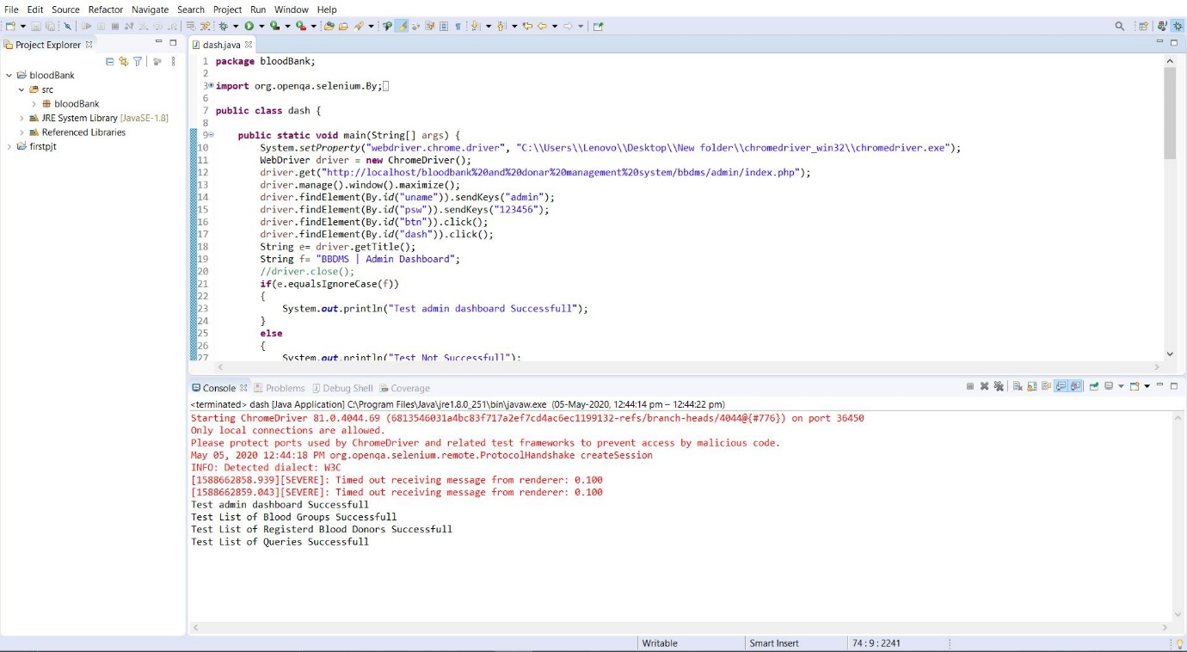

**MANAGE BLOOD GROUPS**

package bloodBank;

import org.openqa.selenium.By;

import org.openqa.selenium.WebDriver;

import org.openqa.selenium.chrome.ChromeDriver;

public class manage {

public static void main(String[] args) {

System.setProperty("webdriver.chrome.driver","C:\\Users\\Lenovo\\Desktop\\

New folder\\chromedriver_win32\\chromedriver.exe");

WebDriver driver = new ChromeDriver();

driver.get("http://localhost/bloodbank%20and%20donar%20management%

20system/bbdms/admin/dashboard.php");

driver.manage().window().maximize();

driver.findElement(By.id("uname")).sendKeys("admin");

driver.findElement(By.id("psw")).sendKeys("123456");

driver.findElement(By.id("btn")).click();

driver.findElement(By.id("man")).click();

String a= driver.getTitle();

String b= "BBDMS | Admin Manage Blood groups";

if(a.equalsIgnoreCase(b))

{

System.out.println("Test List of Blood Groups Successfull");

}

else

{

System.out.println("Test Not Successfull");

}

driver.close();

}

}

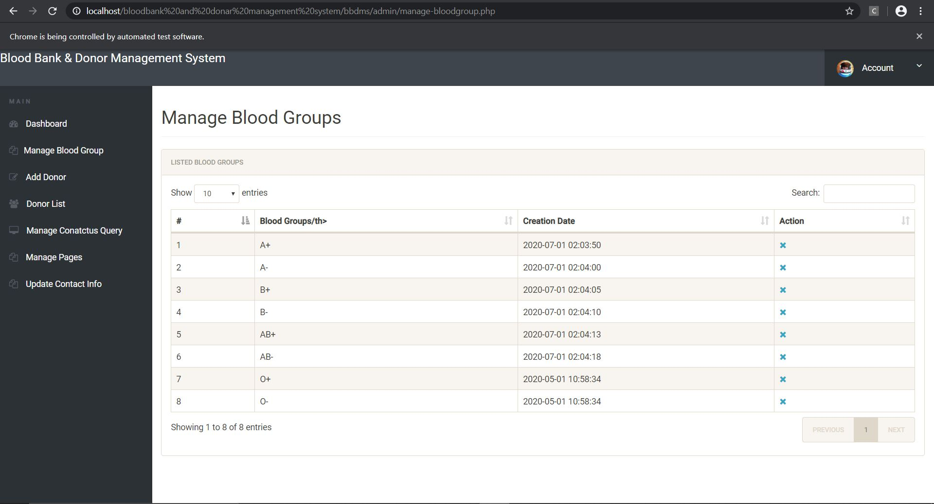

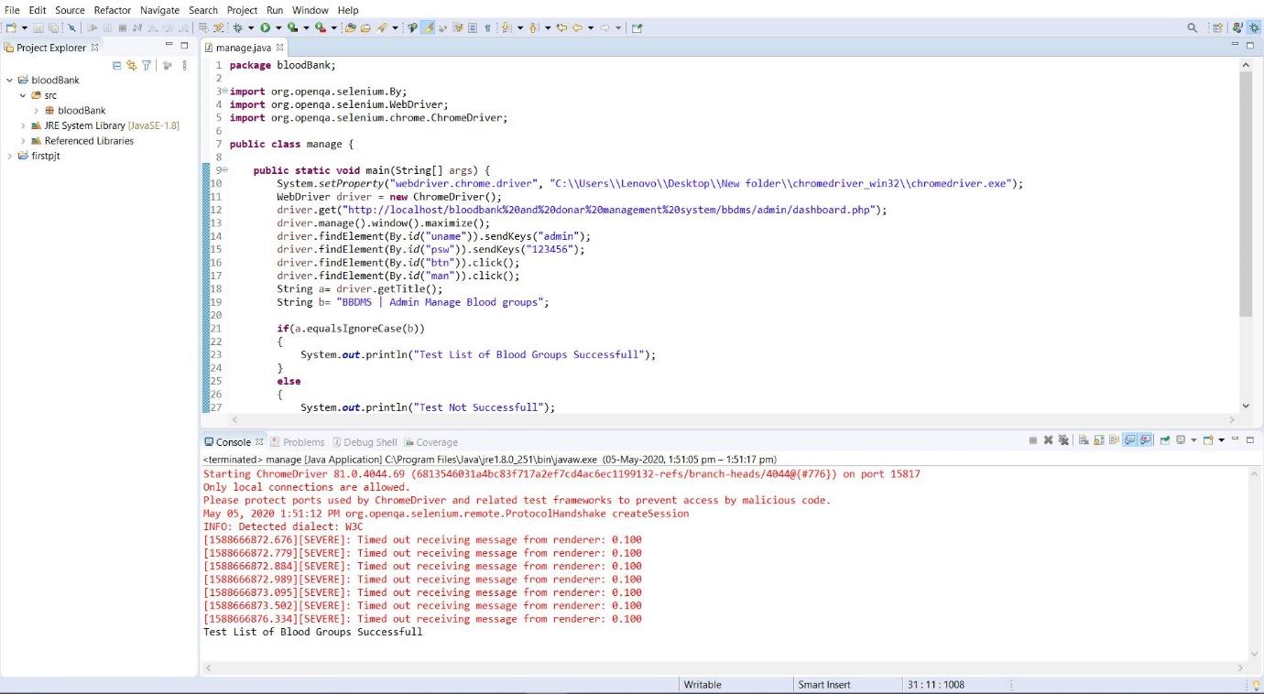

**ADD DONOR**

package bloodBank;

import org.openqa.selenium.By;

import org.openqa.selenium.WebDriver;

import org.openqa.selenium.chrome.ChromeDriver;

public class adddonor {

public static void main(String[] args) {

System.setProperty("webdriver.chrome.driver", "C:\\Users\\Lenovo\\Desktop\\

New folder\\chromedriver_win32\\chromedriver.exe");

WebDriver driver = new ChromeDriver();

driver.get("http://localhost/bloodbank%20and%20donar%20management%20system

/bbdms/admin/index.php");

driver.manage().window().maximize();

driver.findElement(By.id("uname")).sendKeys("admin");

driver.findElement(By.id("psw")).sendKeys("123456");

driver.findElement(By.id("btn")).click();

driver.findElement(By.id("fname")).sendKeys("mm");

driver.findElement(By.id("mob")).sendKeys("9876543210");

driver.findElement(By.id("mail")).sendKeys("manjima@gmail.com");

driver.findElement(By.id("age")).sendKeys("25");

driver.findElement(By.id("add")).sendKeys("Noorumparayil");

driver.findElement(By.id("msg")).sendKeys("none");

driver.findElement(By.id("gn")).sendKeys("Female");

driver.findElement(By.id("bg")).sendKeys("A+");

driver.findElement(By.id("btn")).click();

String e= driver.findElement(By.className("succWrap")).getText();

String f= "SUCCESS:Your info submitted successfully";

if(e.equalsIgnoreCase(f))

{

System.out.println("Doner Submit Test Succesfully Completed");

}

else

{

System.out.println("Test Not Successfull");

}

//driver.close();

}

}

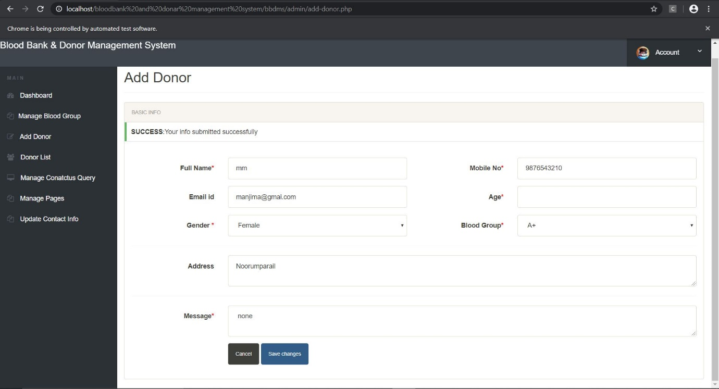

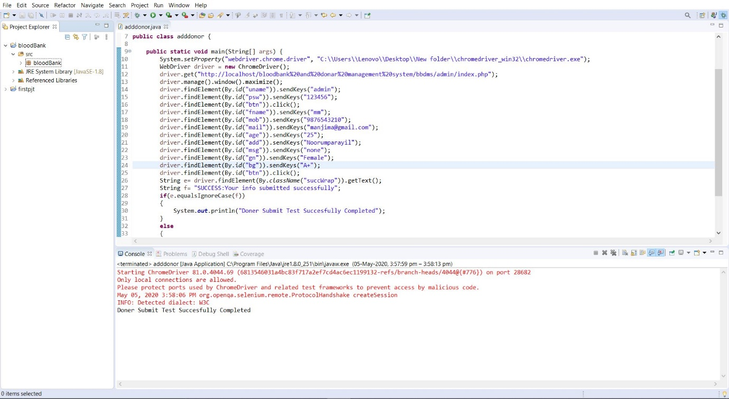

**DONOR LIST**

package bloodBank;

import org.openqa.selenium.By;

import org.openqa.selenium.WebDriver;

import org.openqa.selenium.chrome.ChromeDriver;

public class donorlist {

public static void main(String[] args) {

System.setProperty("webdriver.chrome.driver", "C:\\Users\\Lenovo\\Desktop\\

New folder\\chromedriver_win32\\chromedriver.exe");

WebDriver driver = new ChromeDriver();

driver.get("http://localhost/bloodbank%20and%20donar%20management%

20system/bbdms/admin/index.php");

driver.manage().window().maximize();

driver.findElement(By.id("uname")).sendKeys("admin");

driver.findElement(By.id("psw")).sendKeys("123456");

driver.findElement(By.id("btn")).click();

driver.findElement(By.id("do")).click();

String e= driver.getTitle();

String f= "BBDMS | Donor List";

//driver.close();

if(e.equalsIgnoreCase(f))

{

System.out.println("Test Donor List Successfull");

}

else

{

System.out.println("Test Not Successfull");

}

}

}

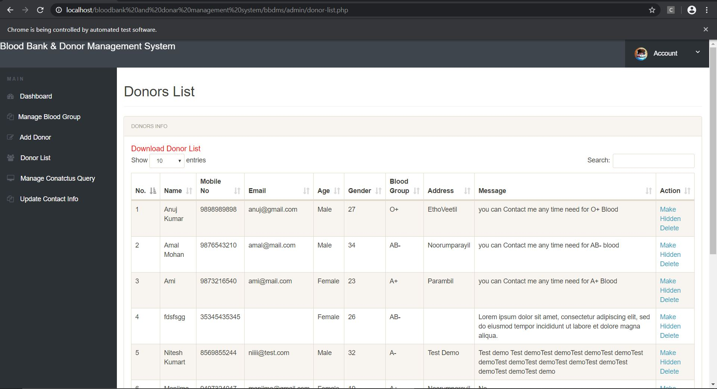

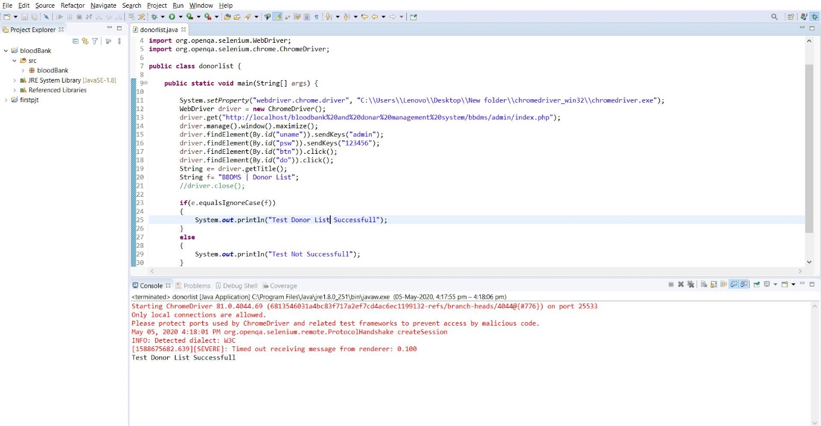

**MANAGE QUERIES**

package bloodBank;

import org.openqa.selenium.By;

import org.openqa.selenium.WebDriver;

import org.openqa.selenium.chrome.ChromeDriver;

public class mngcnt {

public static void main(String[] args) {

System.setProperty("webdriver.chrome.driver", "C:\\Users\\Lenovo\\Desktop\\

New folder\\chromedriver_win32\\chromedriver.exe");

WebDriver driver = new ChromeDriver();

driver.get("http://localhost/bloodbank%20and%20donar%20management%

20system/bbdms/admin/index.php");

driver.manage().window().maximize();

driver.findElement(By.id("uname")).sendKeys("admin");

driver.findElement(By.id("psw")).sendKeys("123456");

driver.findElement(By.id("btn")).click();

driver.findElement(By.id("con")).click();

String e= driver.getTitle();

String f= "BBDMS |Admin Manage Queries";

//driver.close();

if(e.equalsIgnoreCase(f))

{

System.out.println("Test Manage Queries Successfull");

}

else

{

System.out.println("Test Not Successfull");

}

}

}

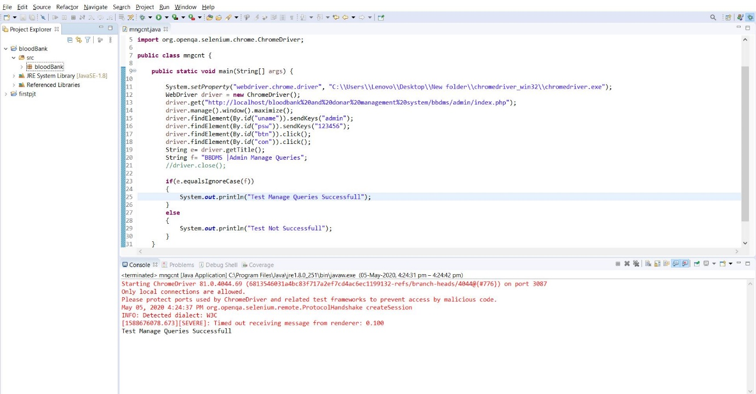

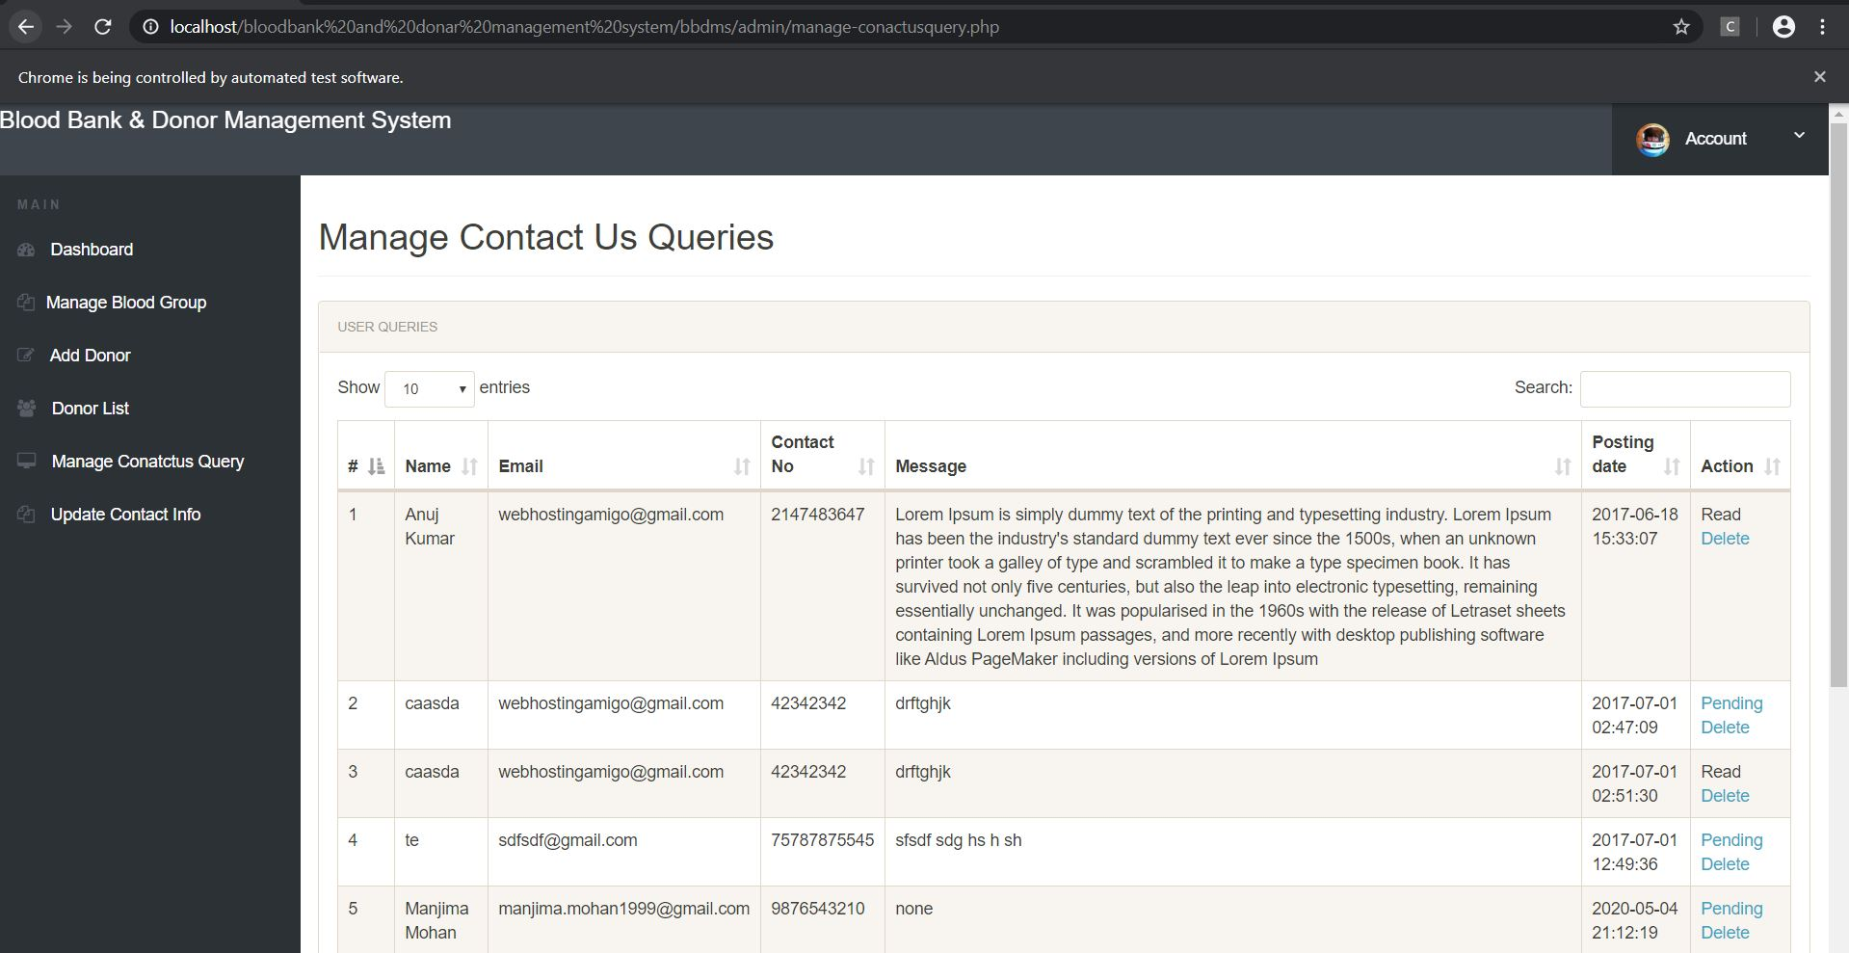

**UPDATE CONTACT**

package bloodBank;

import org.openqa.selenium.By;

import org.openqa.selenium.WebDriver;

import org.openqa.selenium.chrome.ChromeDriver;

public class update {

public static void main(String[] args) {

System.setProperty("webdriver.chrome.driver", "C:\\Users\\Lenovo\\Desktop\\

New folder\\chromedriver_win32\\chromedriver.exe");

WebDriver driver = new ChromeDriver();

driver.get("http://localhost/bloodbank%20and%20donar%20management%20system/

bbdms/admin/index.php");

driver.manage().window().maximize();

driver.findElement(By.id("uname")).sendKeys("admin");

driver.findElement(By.id("psw")).sendKeys("123456");

driver.findElement(By.id("btn")).click();

driver.findElement(By.id("up")).click();

driver.findElement(By.id("address")).clear();

driver.findElement(By.id("email")).clear();

driver.findElement(By.id("contactno")).clear();

driver.findElement(By.id("address")).sendKeys("Noorumparayil");

driver.findElement(By.id("email")).sendKeys("manjima@gmail.com");

driver.findElement(By.id("contactno")).sendKeys("9207857719");

driver.findElement(By.id("btn")).click();

String e= driver.findElement(By.className("succWrap")).getText();

String f= "SUCCESS:Info Updateed successfully";

if(e.equalsIgnoreCase(f))

{

System.out.println("Contact Update Test Succesfully Completed");

}

else

{

System.out.println("Test Not Successfull");

}

}

}

